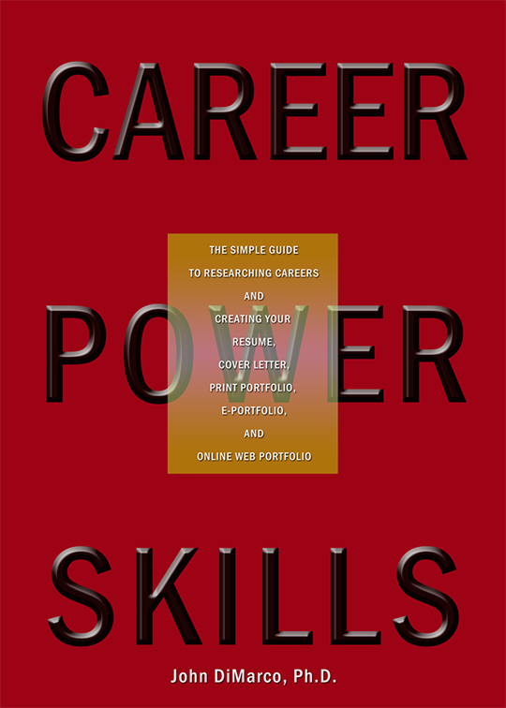
Exercise 1-2
INDUSTRY Research: Job and keyword List.
(READ UP TO PAGE 11 IN THE BOOK BEFORE COMPLETING THIS LIST)
Go to the wesbite BLS.gov.
Research industriesand list job names and associated keywords. Create a list of industries, jobs, and keywords that interest you. The keywords are especially important because you will use them in your resume and cover letter. Look at 2-3 industries, or go directly to the one that most interests you. Use the chart below to build a short blueprint of which industries contain attractive jobs and freelance opportunities. This will allow you to narrow down specific positions to focus on during your job research. Enter important keywords for skills and experience. You will be matching these to your personal abilities later on in the planning process.
Industry name | Job name | Keywords

